.



There is no employee assigned to IT so taken from ‘sales dept’



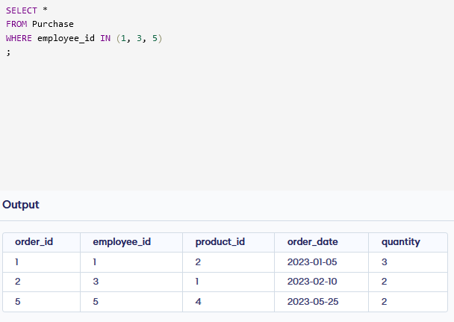

OR





